Meet the Governors of Harting C of E Primary School
The Governors of Harting CofE Primary School would like to introduce themselves; giving some insight into who they are, why they are involved in the management and strategic direction of the school, their involvement in Committees and their terms of office.

Chair of Governors and Local Authority Governor – Jeff Ace

I have lived in the Harting and the Petersfield area since 1994 and had been the Local Authority Governor for just over 2 years before becoming Chair in the 2012/13 academic year.

My background is international business and on retiring trained and qualified as a secondary school mathematics teacher (PGCE).

Throughout my business career I encouraged learning at all levels, for self improvement and the good of the business. This desire for continual education, learning and development I hope I bring to Governorship and to the benefit of the pupils of Harting School.

Head Teacher and Governor (ex Officio) – Fiona Mullett

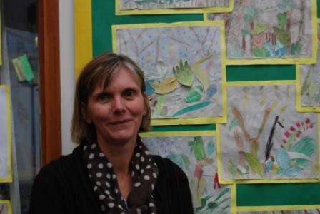
I have worked at Harting School since 2001. Initially this was a part-time teacher whilst I brought up my own children. I have now worked full-time for many years as a class teacher, SENCO and Deputy before become the Head teacher in 2014.

Prior to teaching, I worked for more than a decade at Great Ormond Street Children’s Hospital, as a physiotherapist, which I loved too. This experience taught me about children’s development and their needs, along with the importance of high standards and research.

I remain passionate about doing what is right for children and this motivates me in my work within the school.

Parent Governor – Sheena Hulme

I have lived in South Harting since 2006; I am originally from Cumbria where the mountains are considerably higher than Harting Down!

My two boys have been at Harting School since Reception (my eldest started in 2010 and the youngest 2012). So far my children have loved their time at Harting and I feel they have greatly benefited from the rounded education they are offered.

I am currently an Executive Director at New Theatre Royal, Portsmouth and prior to that I worked for LOCOG at the London Olympic and Paralympic Games. I enjoy playing hockey for Petersfield Ladies 3's and spend much of my leisure time on the side of various sporting pitches cheering on my sons and husband Steve.

I joined the Governing body in October 2012 and sit on the Resource Committee.

Foundation Governor (ex Officio) – The Reverend Mark Morton

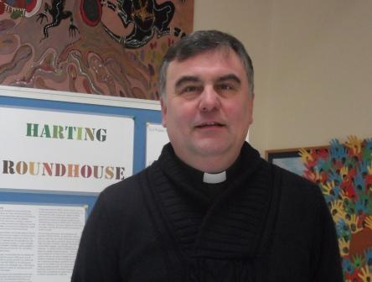
I have served as an ex-officio Foundation Governor since my induction as Rector in November 2011. Ordained in 1992, I spent just over 16 years as an Army chaplain, during which time I was closely involved with a number of schools, either as a governor or as a regular visitor.

Prior to theological training, I worked as a senior investment manager with a firm of stockbrokers and, subsequently, I have studied for two post-graduate degrees. I believe that learning should be stimulating and enjoyable, and that every person should be enabled to reach their full potential, both academically and personally. It is important for children to not only become proficient in core subjects, but to receive the encouragement and support necessary for them to grow into well rounded adults.

I am delighted that Harting School has close links to the local churches, and that a broad Christian ethos is at the heart of all it does.

Parent Governor – Jo Mesney

I moved to Harting with my family in 2011 having previously lived in Chertsey and Hampton. I trained as a primary school teacher fourteen years ago and have taught in a number of schools in outer London and Surrey. I am now thoroughly enjoying teaching a mixed age class at a primary school near Chichester. I have always seen the role of teaching as a privilege and I remain passionate about providing children with a broad range of learning opportunities that are both fun and meaningful.
With two children at the school I became a parent Governor at Harting in 2014. I am very interested in playing a part in the continual development of the school and am keen to support the staff and children in any way I am able.
I enjoy walking our dog on the Downs, horse riding and spending time outdoors with the children. I am also interested in travel, particularly when there is guaranteed sunshine.

Parent Governor – Dr Fiona Heaton

Many of you will know me as Lucy & Oliver’s Mummy. It gives me enormous pleasure to be able to represent the parents as a Governor.

Chris & I moved to Harting in 2007 from the Scottish Borders, within weeks of the move I found out I was pregnant. In 2008 Lucy Mai arrived, followed by Oliver in 2010.

Lucy & Oliver are both incredibly happy at Harting School. I feel passionate about the school and the wider school family.

As a GP I have worked in many of the towns and villages surrounding Petersfield before taking up a salaried post in Portsmouth in 2011. I qualified from Cambridge University in 2002 having studied undergraduate medicine at the University of St. Andrews.

As a family we enjoy walks on the Downs. Over the last two years we have spent our holidays in Port Isaac in North Cornwall enjoying cliff walks and surfing.

Co-opted Community Governor – Ciani Foulkes

Having lived in South Harting since 2004, I have grown to appreciate not only the natural beauty of its South Downs setting, but especially the strong sense of community, particularly where the children of the village are concerned.

I am originally from Romania. I relocated to the UK at the age of 18, completed a Business Studies degree and the professional Chartered Institute of Management Accountants (CIMA) qualification.

Until my two children enrolled at the school in 2010 and 2012 respectively, I had little knowledge of the British primary level education system. I gradually became more and more involved with the school, from taking on the role of Treasurer for the PTFA to volunteering to listen to children read to agreeing to chair the Parents’ Association in September 2013. The year as chair of the PTFA proved most rewarding and I was thrilled when offered the chance to become a Governor, thus ensuring my long term involvement with the school.

I hope my accountancy skills will benefit the administrative side of the governing body, while my passion for education, sport and technology will prove useful to the children of Harting School.

Foundation Governor – Jane Thwaites

I moved to Elsted with my husband in 2012, after over 20 years living up the road, in Surrey. We love living here and are delighted to be part of the community.

I trained as a nurse back in the 1970s, then qualified as a Midwife and stayed working in that profession for over 20 years, finishing up as a supervisor and manager.

In 2000 I moved into community health, managing a variety of services across West Surrey such as district nursing, Health Visiting, school nursing and prison health care, among others. From 2006 until I retired in March 2015 I worked exclusively in Children’s Community Health services across Surrey, which included management responsibility for the Community Paediatricians, children’s Audiology, children’s community nurses, special school nurses and the children’s therapists (occupational therapy, physiotherapy and speech and language therapy).

All this has given me a keen interest in education and a desire to contribute to the development of our local school, particularly in terms of Christian values.

I appreciate I have a great deal to learn but I hope some of my management skills and knowledge of special needs will assist the Governing body.

We have two daughters both in their 30s and our first grandson was born in May 2015.

Parent Governor – Vida Stewart

With an entire career revolving around education in one form or another, I initially qualified as a speech and language therapist and specialised in working with children with moderate learning difficulties in schools in the Chichester area. I subsequently ran an international consultancy and training business with my husband Neil, which took us to western Africa for a year or so where I worked as principal of a new business college. Since we returned to the UK, my roles have included international manager for an awarding body, and I am currently deputy CEO of another awarding body with a strong ethos to support disadvantaged or disenfranchised learners and encourage their return to learning and work. Additionally I am an elected director on the board of the Federation of Awarding Bodies.
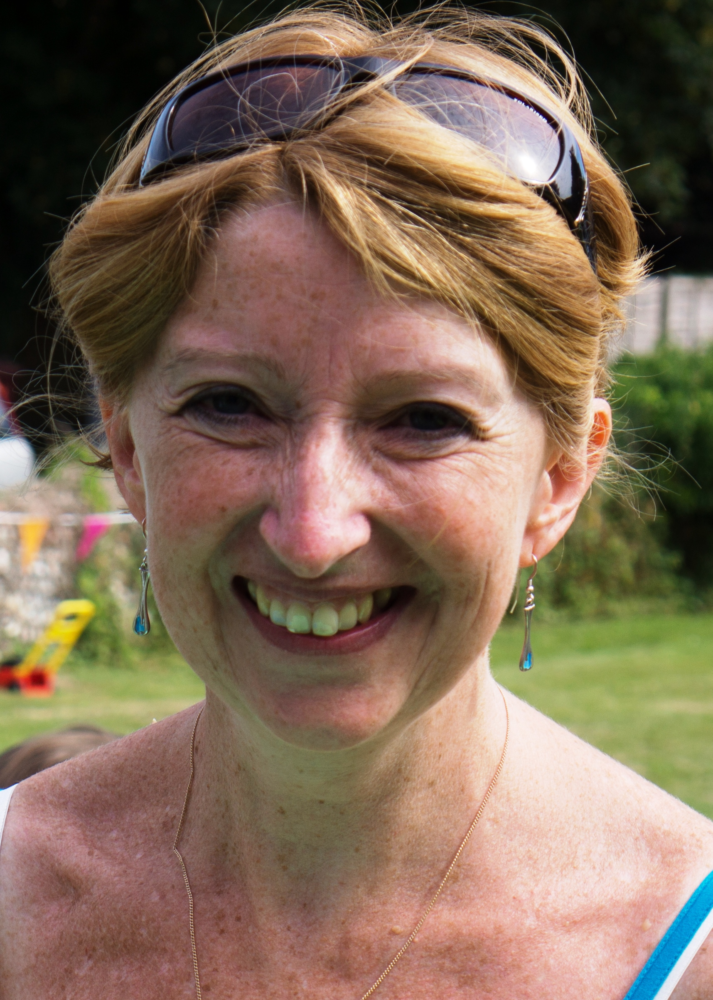

I believe very strongly that children should be safe and happy at primary school, which should be a wholly positive experience to start them off on a road of, and give them a love and hunger for, lifelong learning.

Our son Fraser transferred to Harting School in 2015 from another local school, and we were overwhelmed by the school’s happy, positive atmosphere and the staffs’ supportive approach. We also moved into the village in November 2016, and I feel privileged to be given the opportunity to use my knowledge and skills to support the school and the whole school family, as a parent governor.

Staff Governor - Jane Maybury

Having started my teaching career in London in 2007 I returned to my home ground of Sussex in 2015, when I began teaching at Harting Primary School. I have benefited from working under excellent leaders, who encouraged me to develop myself professionally. I am increasingly able to use this training to reach across schools and larger numbers of children’s lives. As a newly appointed governor at Harting, I aim to work with the school to benefit all pupils.
I take great pleasure from enabling children to love this world as much as I do. When I am not teaching, I can be found walking in the mountains, cycling to work, swimming in wild water and generally seeing the best in the people I meet and in all I experience.

GOVERNING BODY OF HARTING CE PRIMARY SCHOOL
Reconstituted 1 July 2013
The Governing Body consists of 11 members (currently at 10 members) and operates with 3 committees

Full name of Governor | Governor Category | Date of current Appointment or Election | Source of Appointment (where appropriate) | Term  of  office/Roles within GB | Attendance at full GB Meetings* | Committee membership | Attendance at committee meetings* | Declarations on register of business & pecuniary interest | Remarks
Jeffrey Rhys Ace | Local Authority | 4 May 2017 | Local Authority | 3 May 2021  Chair of Governors. | All | Chair of Curriculum Committee. Member of Personnel and Resources Committees | All - with 1 agreed absence from Resources and Personnel | None
Ciani Foulkes | Co-Opted Community | 1 September 2015 | School Governors | 31 August 2019 | All | Chair of Resources Committee. Member of Curriculum Committee | All | None
Fiona Heaton | Parent | 12 December 2014 | Parent Election | 11 December 2018 | All | Chair of Personnel Committee | All | None
Sheena Hulme | Parent | 10 October 2016 | Parent Election | October 2020 | All – with 2 agreed absences | Member of Resources Committee | All | None
Jane Maybury | Staff | 11 November 2016 | Staff | 10 November 2020 | All | Member of Curriculum Committee | All – with 2 agreed absences | None
Joanne Mesney | Parent | 20 July 2014 | Parent Election | 19 July 2018 | All | Member of Personnel Committee | All | None
Full name of Governor | Governor Category | Date of current Appointment or Election | Source of Appointment (where appropriate) | Term  of  office/Roles within GB | Attendance at full GB Meetings* | Committee membership | Attendance at committee meetings* | Declarations on register of business & pecuniary interest | Remarks
Mark Morton | Foundation (ex Officio) | 29 November 2011 | Ex-Officio – Diocese of Chichester | N/A | All - with 1 agreed absence | Member of Personnel Committee | All – with 1 agreed absence | None
Fiona Mullett | Staff (Head) | 1 September 2014 | Staff | N/A | All | Member of Curriculum, Personnel and Resources Committees | All | None
Jane Thwaites | Co-opted Governor changed to Foundation Governor | 12 November 2015  5 October 2016 | School Governors  Diocese of Chichester | November 2019  4 October 2020 | All | Member of Curriculum Committee | All | None
Vida Stewart | Parent Governor | 28 September 2016 | Parent Election | 27 September 2020 | All | Member of Curriculum and Resources Committee | All | None

*Attendance during previous academic year to 31/8/2017

