Science

* Identify that sounds are made when something vibrates and recognise that vibrations from sounds travel through a medium to the ear
* Find patterns between the pitch of a sound and the features of the object
* Recognise that sounds get fainter as the distance from the source increases

Maths

* Measure – telling the time, comparing durations of time
* Measure – perimeter and area of 2D shapes
* Multiplication and division
* Fractions – unit and non-unit fractions including fractions as numbers and amounts

Computing

* Graphics – using print screen, resize, rotate, invert functions
* Animation
* E-safety – How tech might distract from other things in life? When might we need to limit time spent on tech?

Art/DT

* Weaving with rags to illustrate a European landscape – creating initial sketches, cutting, weaving, stitching

[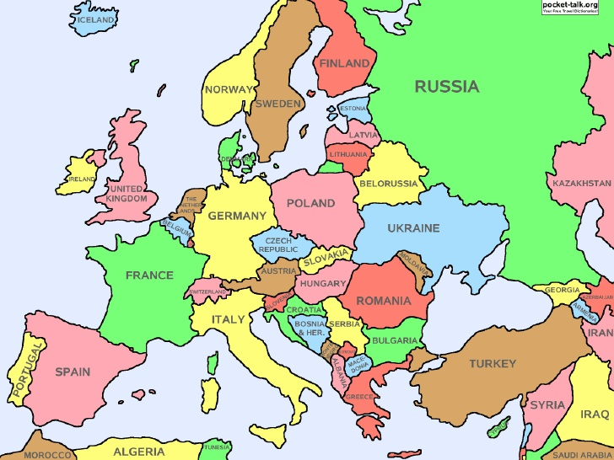](https://www.google.co.uk/url?sa=i&url=https://www.slideshare.net/lschmidt1170/europe-map-study&psig=AOvVaw2jTn6ukfsw2z1xjp8l9np_&ust=1609890959672000&source=images&cd=vfe&ved=0CAIQjRxqFwoTCPCwlKi9g-4CFQAAAAAdAAAAABAE)

Literacy

* All about me
* Persuasive writing
* News report
* Using and punctuating direct speech
* Drawing inferences such as inferring characters’ feelings, thoughts and motives from their actions

PSHE

* Living and the wider world - sharing of economic wealth, meaning of enterprise
* Bullying

Spellings

* Suffixes and prefixes –-ness, -ful, -less, -ly sub-, tele-, anti-, inter-
* Apostrophes for contraction
* Endings - -sion, -cian, -tion, -sure

Geography

* Identifying and recognising continents, countries and capital cities of Europe
* Making comparisons between locations within Europe

Religious Education

* How do questions about Brahman and Atman influence the way a Hindu lives?

French

* Places in town

Physical Education

* Gymnastics
* Developing control
* identify what adaptations are needed to enhance the overall performance

