**Science**

* + To identify that humans and some other animals have skeletons and muscles for support, protection and movement

**English**

*‘Tom’s Sausage Lion’ by Michael Morpurgo*

We will explore the story, developing empathy with the character and making connections to our own lives. We will respond to the story through a variety of genres, focusing on the following writing objectives:

* To use fronted adverbials
* To use commas after fronted adverbials
* To compose and rehearse sentences orally
* To extend sentences with more than one clause by using a wider range of conjunctions
* To use and punctuate direct speech

**Maths**

* Times tables
* Fractions
  + Revision of halves, quarters, thirds
  + Unit fractions
  + Non-unit fractions
  + Equivalent fractions
  + Adding and subtracting fractions
  + Fractions as decimals

**Computing**

* To take photographs
* To upload and save photographs
* To make a stop-motion animation

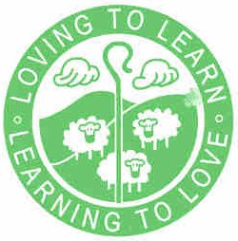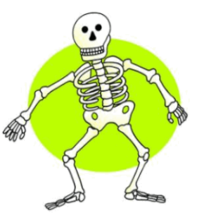

**French**

* Food and healthy eating

**The Human Body**

**Physical Education**

* Strike and field games

**PSHE**

* To understand how we can deal with emotions and make sure we don’t hurt others’ feelings in the process.
* To deepen our understanding of good and not so good feelings and how to deal with them

**Religious Education**

*When Jesus left, what was the impact of Pentecost?*

**Spellings**

* Year 3 and 4 common exception words
* Suffixes: ‘-ly’ (year 3); ‘-ous’, ‘-ion’ (year 4)
* Homophones (year 3)
* The /l/ sound spelt ‘le’ and ‘al’ (year 3)
* The ‘au’ digraph (year 4)