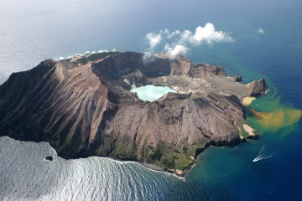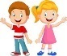

PHSE Living in the wider world; rules, routines

Feelings

Behaviours

P.E

Games with Mr Gardiner

Gym- perform routines using the small equipment

Geography

Locate hot and cold areas of the world in relation to the equator and the North and South poles

Use simple compass directions

Use maps, atlases and globes to locate countries of the world

Use basic geographical vocabulary such as farms, factories, village, city, town, harbour

Art

Mix colours to match those of the natural world

Observe and draw landscapes as accurately as possible

Explore printing using natural and man-made objects

Use string to produce relief printing artwork

R.E

Why is the Torah such a joy for Jewish people?

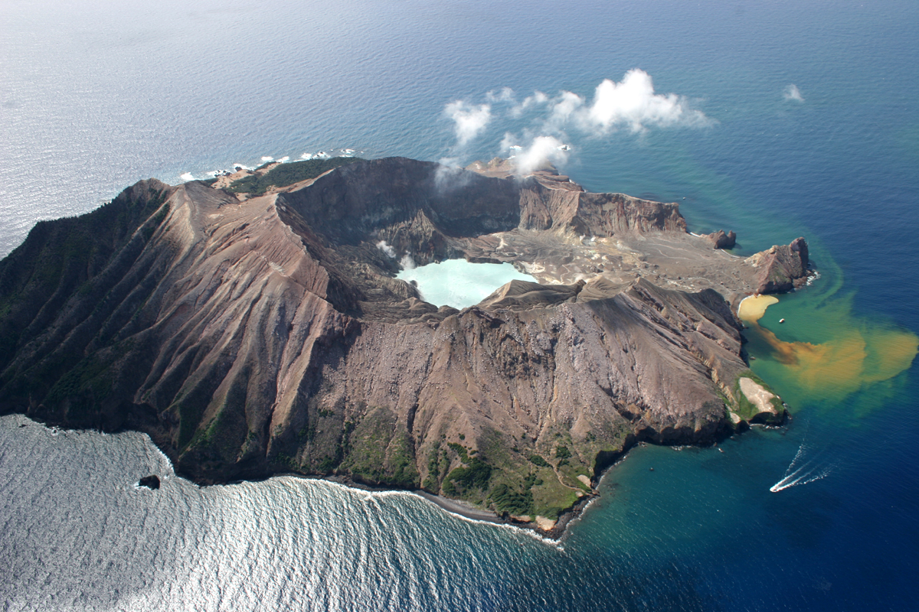

An Island Home

Science

(yr1) identify and name a variety of common animals including fish, amphibians, reptiles and mammals

(yr2) perform a simple test; investigate which materials would be suitable for a raincoat and why

Reading

(yr1) respond quickly with the correct sound for all 40+ phonemes; link what is read to their own experiences

(yr2) read most words quickly and accurately without overt sounding and blending; discuss and clarify the meanings of words

(yr1) sequence sentences to form short narratives; join clauses using ‘and’

(yr2) write for different purposes; proof-read own writing checking for spelling, grammar and punctuation. Daily Phonics and regular handwriting practise for both year groups

Warren Class

Spring 1st half 2021

Computing

E-safety - know how to get help if content is worrying

Word process a short text. Know what the arrow keys, space bar and backspace are used for. Save, retrieve and print work

Contribute to a class email

Maths (yr1)

Count in multiples of 2s, 5s and 10s

Solve one-step problems that involve addition and subtraction including missing number problems

Find a half and a quarter of an object, shape or quantity

(yr2)

Count in steps of 2, 3, 5 from zero and in 10s from any number

Solve problems with addition and subtraction using pictorial representations

Find a half, quarter, three-quarters and a third of a length, shape, set of objects or quantities

Science

Name and label the parts of the body

Five senses

Explore hearing, touch and smell

English

Individual reading

Listening to stories and joining in with predictable phrases

Writing sentences leaving spaces between words (year 1)

Writing sentences using capital letters and full stops (year 2)

Phonics – split digraphs and digraphs

R.E

What do Christians believe God is like?

Discussion, role play,

Tell the story of the Lost Son

Maths

Repeating patterns

1 more, 1 less

Comparing numbers to 100

Place value (year 2)

Measuring (height)

Number bonds to 10

Addition and subtraction facts to 20 (year 2)