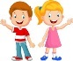

Science - Materials

(yr1)Identify and name a variety of everyday materials, including wood, plastic, glass, metal, water, and rock

(yr2) Find out how the shapes of solid objects can be changed by squashing, bending, twisting and stretching

English

(yr1) apply phonic knowledge and reading skills to decode words

(yr2) improve fluency by improving sight vocabulary and recognition of words with two or more syllables (yr 2)

(yr1) Write sentences leaving spaces between words and begin to use full stops and capital letters.

(yr2) Write short narratives, by joining sentences with ‘because’. Punctuate using full stops, capital letters, exclamation and question marks. Daily Phonics and handwriting practice

Warren Class

Autumn 2nd half 2020

Computing

E-safety - know that anything on-line can be copied

Use the programmable toys (Beebots) – give commands such as forwards, backwards, turn; (yr2) give a set of instructions to form simple geometric shapes.

History

Act the story of Guy Fawkes.

Research toys: looking at the similarities and differences between toys of the past and toys of the present

Toy Story

P.E

Dance - Compose and link movements to make simple dances with clear beginnings, middles and ends

Games

PHSE

Feelings

Behaviours

Geography

Describe seasonal weather changes – autumn and winter

R.E

Why does Christmas matter to Christians?

Activities will focus around the story of the Lost Son

Maths (yr1)

Number bonds to 10 and related subtraction facts

Add and subtract one-digit and two-digit numbers to 20 including zero

Recognise and know the value of different denominations of coins and notes

(yr2)

Number bonds to 20 and related number facts to 100

Add and subtract a two-digit number and ones, a two-digit number and tens, two two-digit numbers

Find different combinations of coins that equal the same amounts of money

Art

Use charcoal to draw

D.T

Explore building with construction kits and recycled materials;

Design and make a toy with a moving part

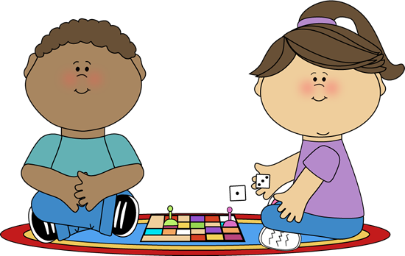

Science

Name and label the parts of the body

Five senses

Explore hearing, touch and smell

English

Individual reading

Listening to stories and joining in with predictable phrases

Writing sentences leaving spaces between words (year 1)

Writing sentences using capital letters and full stops (year 2)

Phonics – split digraphs and digraphs

R.E

What do Christians believe God is like?

Discussion, role play,

Tell the story of the Lost Son

Maths

Repeating patterns

1 more, 1 less

Comparing numbers to 100

Place value (year 2)

Measuring (height)

Number bonds to 10

Addition and subtraction facts to 20 (year 2)