Lit  Encourage children to retell stories we have learnt this term (eg The Very Hungry Caterpillar)  Read daily – either from reading books or via an eBook (see useful websites link).  Handa’s Surprise – read or watch link to story: https://www.youtube.com/watch?v=qGqUVsFMtZs  Follow recipes for healthy meals using different vegetables.  Plan and make a healthy pizza and write down the ingredients and instructions.  Write clues for egg hunts |  | Maths  Measuring parts of our bodies – eg how many pieces of lego fit in my footprint?  Counting and adding with fruit & veg  Play dice and counter board games  Money – Playing shops with tins of food, pennies and cereal boxes etc  Practice drawing and writing numbers  Shape hunt around the house – 2D and 3D shapes
EAD  Sing a range of songs and rhymes  Dressing up  Acting out stories with dolls, small world toys (playmobil, lego, cars etc)  Music – can you make an instrument (shaker/ scraper etc) out of junk model boxes?  Sauce pan tunes (if you’re feeling brave enough)!  Green grocers/ shop role play  Doctors clinic/ baby weigh in role play  Make an Easter garden | Healthy me  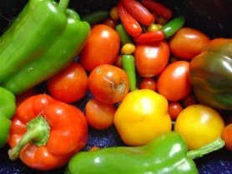  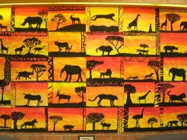 |  | KUW  Handa’s Surprise – Africa. Exotic fruits – taste some if available. Find out about African animals and find Africa on the globe.  Look at African art – eg sunsets and silhouettes (see pic)  Paint/ draw in the style of above  Printing with fruit/ veg/ potatoes  Avocado Baby – how we grow/ sequencing/ personal timeline?  How else could we grow strong? Keep fit etc this week. Family trees – draw all of your family and stick them onto a painting of a tree  Easter/ Easter story
PD  How can we keep healthy? – Food, exercise, hygiene etc  Can we make a healthy pizza?  Mark making/ drawing and handwriting practice |  | PSED  Making & tasting something new  Likes & dislikes – do we all like the same things?  Hand washing & personal hygiene

