Religious Education-friendship, forgiveness, peace

* Jesus is a friend to the friendless-the tax collector (Matthew Chapter 9 vs 9-13) learn about the story
* Retell the story of the good Samaritan.
* How do Christians love their neighbour?
* ‘Christians say Jesus is good news because…’ ‘Good news to me means…’

Science-How do the seasons change and differ?

* How the seasons change-observe and note changes. Look back at photographs taken at different times of the year and discuss.
* Read a thermometer to measure temperature

Literacy

* Write superhero descriptions and stories
* Parable (RE) story – re-tell a story with a message
* Read for inference-short poems: talk about feelings from poems read
* Read comics and superhero stories
* Use full stops for I, names, days of the week, months and sentence starters
* Read own writing back to an adult
* Spell the days of the week
* Know terms ‘singular’ and ‘plural’
* Make a Diary of a Superhero

Maths

* Finding half of a shape and quantities <http://resources.hwb.wales.gov.uk/VTC/ngfl/ngfl-flash/fractions/fractions.html>
* Add and subtract one digit numbers to 20-by counting back, crossing out and covering up objects when subtracting
* Reading time to the half hour and o’clock <http://www.scootle.edu.au/ec/viewing/L9643/index.html>
* Counting in 2s and 10s
* Counting on from a number when adding two numbers together <https://www.topmarks.co.uk/learning-to-count/helicopter-rescue>
* Count and read numbers to 100-https://www.topmarks.co.uk/place-value/place-value-charts
* Reading a thermometer (science link)
* Tax collector money role-play (RE) <https://www.topmarks.co.uk/money/coins-game>

Use resources for all calculating and problem solving. spoons and forks, pieces of lego or any other toy of which you have many would all be fine for this purpose.

Additional resources: <http://www.ictgames.com/mobilePage/corona/schoolClosureSuggestionsY1.pdf>

Superheroes

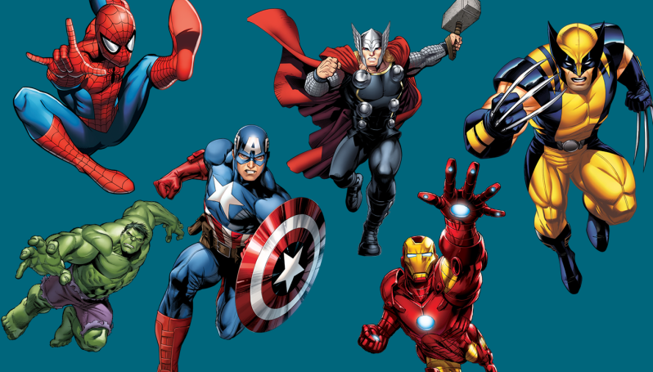

History

* Significant individuals and historical events
* Shackleton’s voyage to Antarctica
* Other famous people

Physical Education

* Dance- pretend to be a superhero
* Dance imaginatively
* Change speed level and direction in dance
* Make up and perform a dance

PSHE

Talk about how:

* children can contribute to their school and world
* Rights of ALL living things and related responsibilities
* Special people in the community

DT/ART

* Patterns, printing and textiles
* Relief printing using string on card
* Print by drawing into polystyrene sheets
* Design and make a superhero’s cape

Computing using PAINT or a similar application/system

* Insert shapes
* Rotate shapes
* Change colour and fill shapes with colour
* Use a range of brush types and thicknesses
* Touch typing using DANCEMAT typing online.